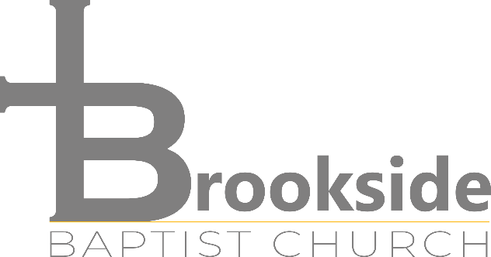

Biblical Counseling
“For the glory of God and the joy of His children.”
Mission statement:
To glorify God by proclaiming the gospel to the whole creation, making disciples of Jesus Christ who are rooted and built up in Him, by establishing them in the faith through the Word of God, which is sufficient for life and godliness and able to equip the believer for every good work, wherein he will find fullness of joy (Psalm 16:11; Matthew 28:19; Mark 16:15; Colossians 2:7; 2 Timothy 3:16-17; 2 Peter 1:3).
What We Believe:
The Bible tells us that humanity was created with a physical body and an immaterial, eternal soul for the purpose of glorifying God. Being in the presence of God and in right relationship with Him, the first man and woman experienced fullness of joy. This bliss, however, did not last. Because of its disobedience and rebellion, mankind could no longer enjoy God's presence, and the whole creation fell under a curse; it plummeted into physical and spiritual death and decay. But God, rich in mercy, made a way for His glory and human joy to be accomplished in people, once again. By faith in the perfect sacrifice of Jesus Christ as payment for sin and acceptance of His perfect righteousness, both of which were validated by His resurrection from the dead, people can be reconciled to God and begin to understand what it means to glorify and enjoy their Creator. Brookside Baptist Biblical counselors seek the privilege of participating in this wonderful story, by coming alongside those who are suffering from the physical and spiritual consequences of sin and a cursed world and teaching them how to live according to their purpose (Genesis 3; Proverbs 24:11; Matthew 22:37; Ephesians 2:1-10).
What is Nouthetic Counseling?
The Greek word nouthesia or noutheteo appears several times in the New Testament (e.g. Acts 20:31, Romans 15:14, I Thessalonians 5:14). It is translated “admonish, warn, or instruct”. Nouthetic (Biblical) counseling upholds the sufficiency of the Scriptures as the source of answers, healing, and change. We are confident that the Bible has all the information necessary for life and godliness. There are no problems in our personal lives and between persons that the Bible does not generally or specifically address. All counseling will be conducted according to the counselor’s understanding of Scripture, which is according to a literal, historical, hermeneutical approach.
General Practice

1) Counseling is provided on a no-fee, offering-only basis. We do incur significant operating expenses and therefore, request that some offering be given. However, we feel impressed to allow each person to determine the amount he/she is able to give.
2) Every Biblical counselor is accountable to our local church body, Brookside Baptist Church. We will, at times, seek Biblical advice from our pastor or another counselor without divulging identifying information.
3) Counselors are certified (or in the certifying process) with the Association of Certified Biblical Counselors (ACBC) and/or the International Association of Biblical Counselors (IABC) and/or the Fellowship of Biblical Counselors (FBC).
4) Information disclosed in counseling sessions will be held confidential only as the counselor believes the Bible requires. Absolute confidentiality is not Scriptural; under certain circumstances matters of church discipline and safety issues require disclosure of facts to appropriate legal or spiritual authorities. The counselee will be informed before any such disclosures are made.
5) At any time during the counseling, for reasons sufficient to himself, the counselor (as also the counselee) shall have the option of terminating counseling.
6) Biblical counseling at Brookside Baptist Church is free, as a service and blessing to our community. It is important that you attend all scheduled appointments. However, in the case of an emergency we ask at least 24-hours notice to reschedule. Should three cancellations occur, you will be placed on our waiting list for an available time slot to resume Biblical counseling. Others are waiting for counselors, and we must make the best use of our counselors’ time. Also, since Biblical counseling works when you work, negligence in completing three homework assignments will warrant termination of Biblical counseling.
7) It should be understood that Biblical counseling consists of the giving of Scriptural advice and the practical application of the same to each individual. Yet, the counselee is held fully responsible for how he or she implements that advice. As Biblical counseling, no state licensure or compliance is maintained or implied. The Biblical counselors at Brookside Baptist Church are not licensed therapists, psychologists, or Licensed Professional Counselors and are exempt from laws regulating professional counselors in the State of Texas under Section 503.054 of the Licensed Professional Counselor Act.

We look forward to prayerfully and Scripturally working with you as you seek hope and change.

For His glory,
Brookside Baptist Church Biblical Counseling

I agree to enter into counseling accordance with the statements listed in this paper.
Signed:___________________________________________________________Date:________________
Signed:___________________________________________________________Date:________________
Guardian:_________________________________________________________Date:________________

